REPUBLIKA SLOVENIJA
MINISTRSTVO ZA FINANCE
Šmartinska cesta 55, 1000 Ljubljana tel.: +386/1/478-2884 fax.: +386/1/478-2746

DIPLOMATS- Request for tax refund
(DP-VRA)

User instructions

© Republic of Slovenia - Ministry of Finance
Reproduction in parts or in whole, in any way and in any medium, is not allowed without the written permission of the Ministry of Finance. Violations are sanctioned in accordance with the law.

Table of contents
1. Introduction 3
2. Value and quantity limits 3
2.1 Value limits 3
2.1.1 The minimum total amount of exemption 3
2.1.2 The maximum total amount of VAT exemption for personal needs 3
2.2 Quantity limitations for products subject to excise duty 4
2.2.1 Purchase of products subject to excise duty for personal needs 4
2.2.2 Purchase of products subject to excise duty for official use 4
3. eDavki Portal 5
4. Entry of data into the claim 8
4.1 Document type and period 9
4.2 Data of the entitled person 9
4.3 Contact person 9
4.4 Bank account 10
4.5 Data of the basic certificate 11
4.6 Purchases of goods/services 11
4.6.1 Data about the invoice 13
4.6.2 VAT 14
4.6.3 EXCISE DUTIES 16
4.6.4 Finishing the entry of data on the invoice and adding the next invoice 18
4.6.5 Deleting, editing and checking the data on the invoices 19
4.7 Import and export of data about invoices (excel aid) for the purchased goods/services 20
4.7.1 Import of data about invoices 20
4.7.2 Export of data about invoices into Excel 23
4.8 Attachments 24
4.8.1 Adding attachments before filing the claim (attachments included) 24
4.8.2 Adding attachments on a claim already filed (naknadne priloge - NF-Priloga / subsequent attachments – NF-Attachment) 25
4.9 Search engine for invoices 29
4.10 Submission of the tax refund claim 30
4.11 Reversing of the document (Withdrawal of the tax refund claim) 34
5. Received documents (administrative acts, issued by the tax authority) 37

Introduction
Upon fulfilling certain conditions, the entitled person can claim a refund of the tax paid (VAT and excise duties), which was charged to him or his family member by suppliers, identified for VAT purposes in Slovenia, on the purchase of goods and services.

An entitled person established in Slovenia files a refund claim for the period of at least one calendar quarter or for a maximum of a calendar year. A quarterly claim can be filed no later than 60 days after the end of the calendar quarter, while an annual claim can be filed by June 30 of the current year for the preceding year.

The entitled person files a tax refund claim (DP-VRA – hereinafter referred to as the claim) through the eDavki portal and, upon request of the tax authority, attaches the invoices based on which such person claims a refund of the tax paid.

Legal bases are as follows:
- Articles 50 and 54 of Zakon o davku na dodano vrednost – ZDDV-1 (Value Added Tax Act),
- Article 17 of Zakon o trošarinah - ZTro-1 (Excise Duty Act),
- Pravilnik o pogojih in načinu oprostitve davkov za diplomatska predstavništva, konzulate, agencije in organe Evropske unije ter mednarodne organizacije v skladu z mednarodnimi pogodbami, ki obvezujejo Republiko Slovenijo (Rules on the conditions and methods of tax exemption for diplomatic missions, consulates, agencies, and bodies of the European Union as well as international organizations in accordance with international agreements binding on the Republic of Slovenia) – hereinafter: the rules,
- treaties, protocols, or agreements to which the Republic of Slovenia is a contracting party.

Value and quantity limits

Value limits

The minimum total amount of exemption
The minimum amount of the value of goods or services purchased on an individual invoice, including tax, is set by the Ministry of Foreign and European Affairs (Diplomatic Protocol) on the basic certificate. This value limit does not apply to the purchase of electricity used as fuel for the vehicles of entitled persons.

The maximum total amount of VAT exemption for personal needs

The maximum total amount of VAT exemption in the calendar year – diplomatic staff

For an individual calendar year, for the purchases of goods and services up to the total amount of the exemption set in the basic certificate for an individual country, agency, or EU body and international organization or its representation by the Ministry of Foreign and European Affairs (Diplomatic Protocol), the following persons:
- diplomatic agents of diplomatic missions together with family members,
- consular officers (except honorary consular officers) and their family members,
- members of the diplomatic staff of EU agencies and bodies together with family members, and
- members of the diplomatic staff of international organizations or representations of international organizations and their family members
claim the exemption through a refund of the tax paid.
The following conditions also apply to all the persons mentioned above:
- that they are not citizens of the Republic of Slovenia or do not have permanent residence in the Republic of Slovenia,
- for family members that they also must live in the same household with the diplomatic staff.

The maximum total amount of VAT exemption in the first 12 months of arrival for service in the Republic of Slovenia – administrative and technical staff

Members of the administrative and technical staff of:
- diplomatic missions and consulates (except for members of consular staff headed by honorary consular officers) and
- agencies and bodies of the European Union, as well as international organizations or representations of international organizations
may claim a refund of VAT paid in the first year following their arrival to their service in the Republic of Slovenia, specifically for the purchase of household items up to a maximum of 1,200 euros in total exemptions, or in accordance with the limitations set in the basic certificate by the Ministry of Foreign and European Affairs (Diplomatic Protocol).

Quantity limitations for products subject to excise duty

Purchase of products subject to excise duty for personal needs
In each calendar quarter, the following persons:
- diplomatic agents of diplomatic missions together with their family members,
- consular officers (except honorary consular officers) and their family members,
- members of the diplomatic staff, agencies and bodies of the European Union together with their family members,
- members of the diplomatic staff of international organizations or representations of international organizations and their family members, and
- members of the administrative and technical staff of diplomatic missions and consulates (except for consulate staff headed by honorary consular officers)
claim an exemption in the form of a refund of tax on the purchase of electricity used as a motive fuel, for up to 2,000 kWh for each electric vehicle that is registered in the Republic of Slovenia and is owned or under financial or operational lease by the entitled person and intended for road traffic.

For other products subject to excise duty, quantity limits are not prescribed because the above-mentioned entitled persons can claim a refund of the excise duty as long as they can claim a refund of the paid VAT (see chapter 2.1.2).

Purchase of products subject to excise duty for official use
Diplomatic missions and consulates in Slovenia, agencies, bodies or representations of the European Union in Slovenia, and international organizations or representations of international organizations in Slovenia if exemptions from tax payment are set by international agreements to which the Republic of Slovenia is a contracting party, may, in an individual calendar quarter, claim the exemption in the form of a refund of the paid tax (VAT and excise duties) on the purchase:
− electricity used as a fuel, up to 4,000 kWh for each electric vehicle that is registered in the Republic of Slovenia and is owned or under financial or operational lease of the entitled person and intended for road traffic;
− alcohol and alcoholic beverages, namely up to:
- 90 liters of wine, including up to 60 liters of sparkling wine,
- 120 liters of beer,
- 20 liters of other alcoholic beverages;
− tobacco products, namely up to:
- 50 pieces of cigarillos,
- 30 pieces of cigars,
- 1,000 pieces of cigarettes.
At claiming of a refund of the tax paid in a given calendar quarter for other products subject to excise duty there are no quantity limits prescribed.

eDavki Portal
eDavki Portal is located on the following link https://edavki.durs.si/.

After successful registration and logging into the eDavki portal, if submitting a request for oneself, select yourself (marked in yellow in the image). If submitting a request for a represented person from the list, click on that person in the list (marked in red in the image).

For the purposes of this document, a user is considered to be an entitled person or a person who submits a claim on behalf of the entitled person.
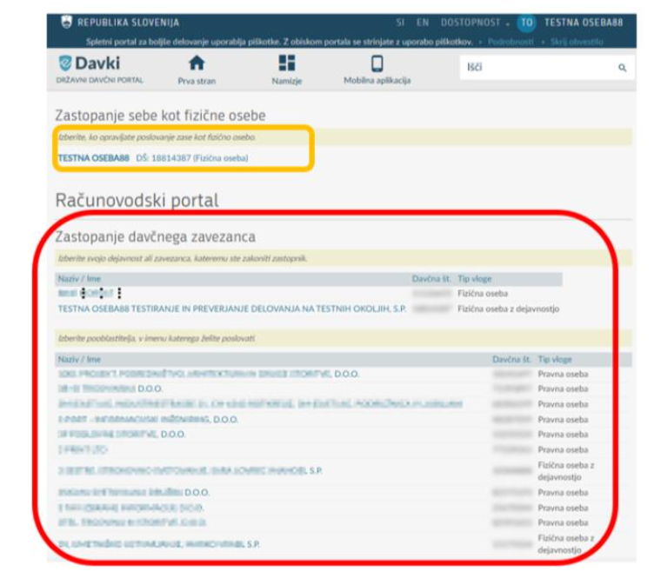

If you click on the represented person, the desktop of the represented person opens, where in the left side menu the section »Upravičenci MZEZ« (MZEZ Entitled persons) is selected/clicked.
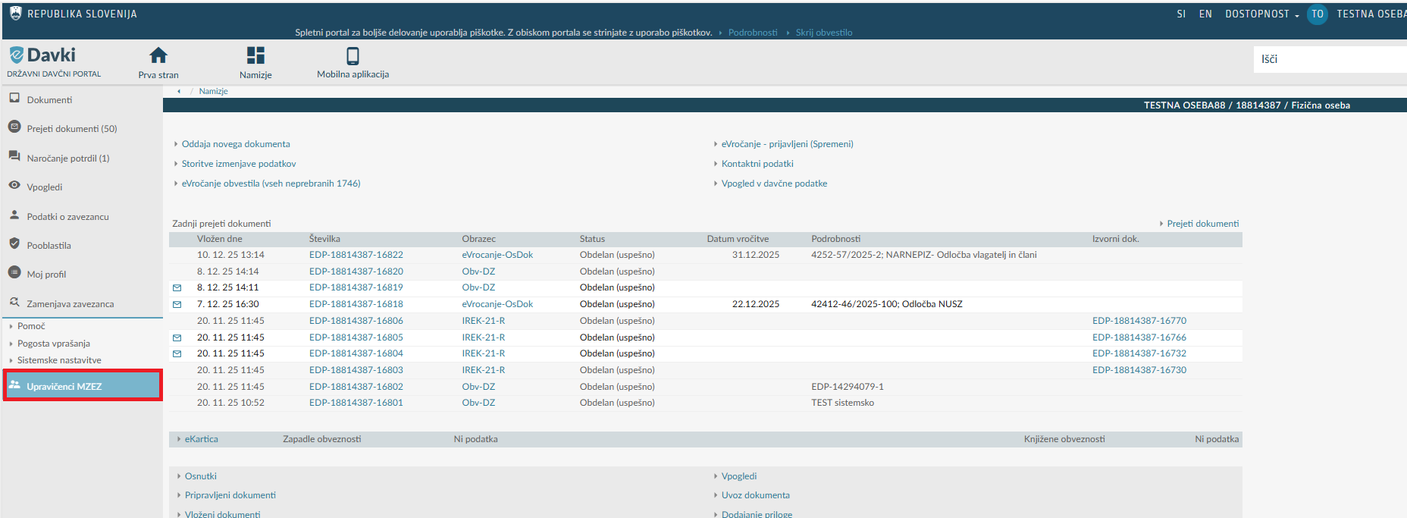
A new page opens, on which »Zahtevek za vračilo davka« (Tax Refund Claim) is selected. By clicking on »Zahtevek za vračilo davka« (Tax Refund Claim), the »Zahtevek za vračilo davka« (Tax Refund Claim) opens, into which the required data must be entered.

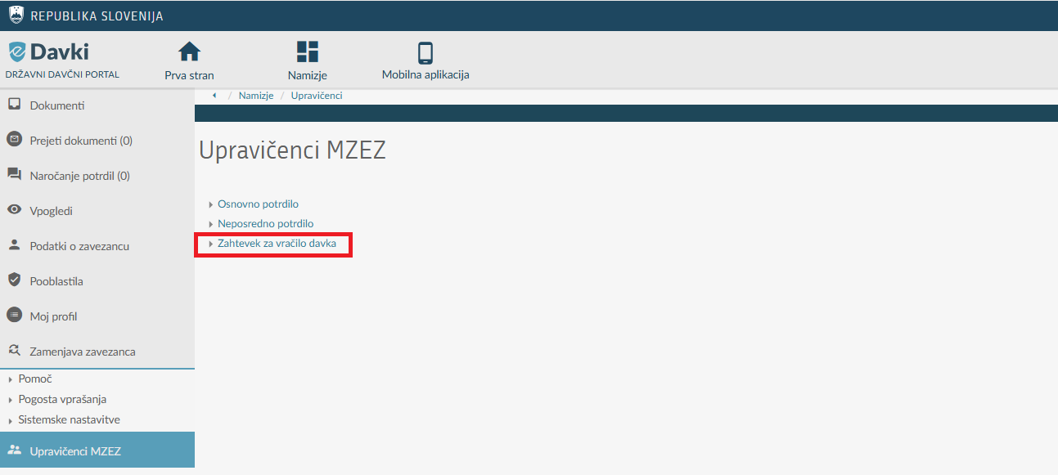
WARNING: The claim is opened if the represented person has or has ever had a basic certificate issued in the past. If the Ministry of Foreign and European Affairs (Diplomatic Protocol) has not issued the basic certificate, submitting the »Zahtevek za vračilo davka« (Tax Refund Claim) is not possible (the system will report an error).

A page opens to the user before going to the actual claim, where the desired period (quarter or year) of the tax refund claim is selected. The user can choose from the refund periods that can be submitted on the current day.

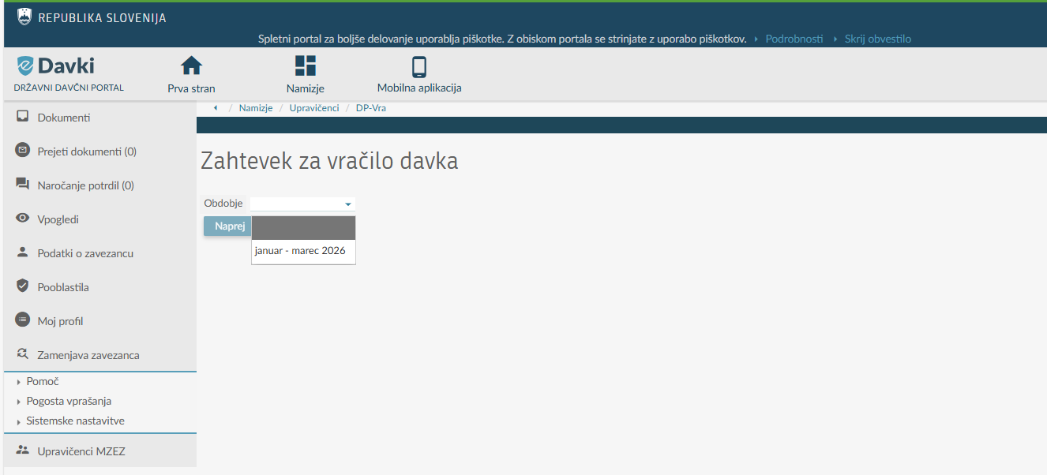

After selecting the period, click the »Naprej« (Next) button.
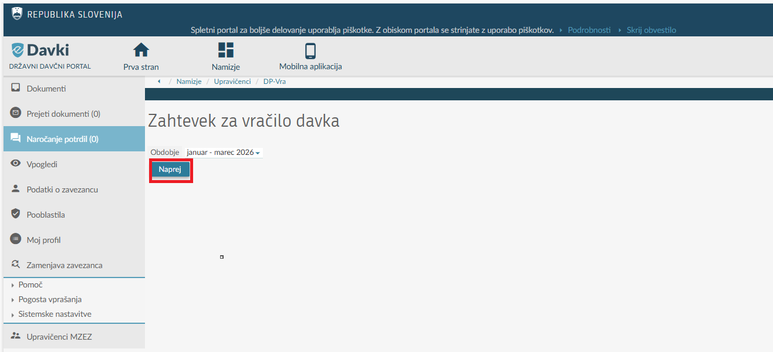

The »Zahtevek za vračilo davka« (Tax Refund Claim) opens, into which the data are entered.
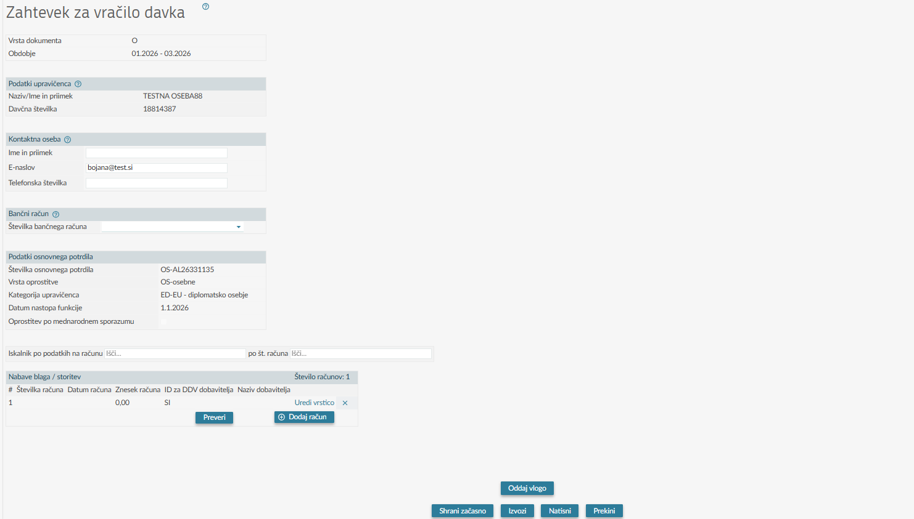

Entry of data into the claim
The claim includes the following sections of data:
- Document type and period
- Data of the entitled person
- Contact person
- Bank account
- Data of the basic certificate
- Purchases of goods/services
  - Data on the invoice
  - VAT
  - Excise duties
- Import and export of data on invoices

Document type and period
When opening a claim, the data about the claim period, which the user has selected on the preceding page, and the type of document (O - Original) are prefilled.
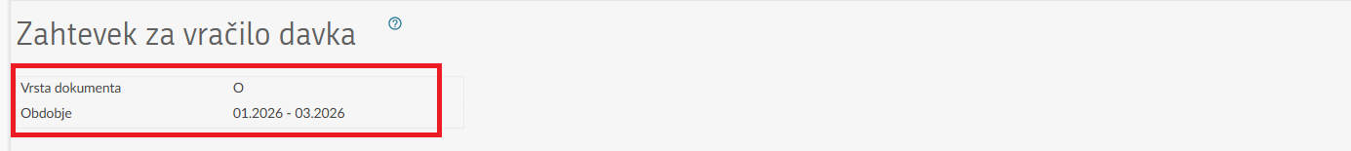

Data of the entitled person
The data about the entitled person (name/surname, tax number) are prefilled based on data from the Register of taxable persons (RDZ) and cannot be changed in this claim.

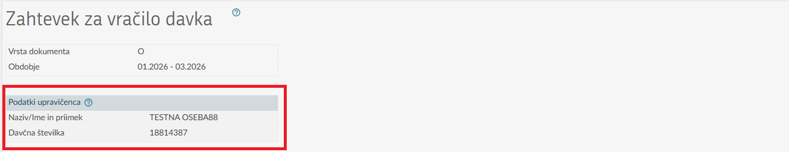

Contact person
The first name and surname, email address, and phone number of the contact person, whom the tax authority can contact in connection with the claim, are entered.

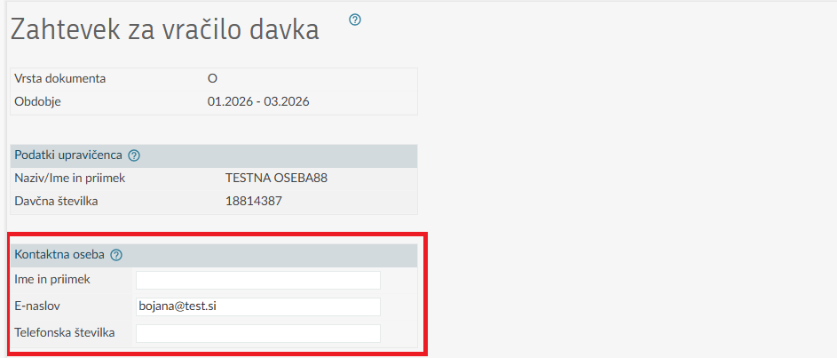

The data about email address is pre-filled with the email address provided in the last submitted application from the field of the »Upravičenci MZEZ« (MZEZ Entitled Persons) functionality. The entitled person receives notifications about documents uploaded on the eDavki portal, which were issued to such person by the tax authority (issued administrative acts).

Bank account
A bank account is selected from the dropdown menu. The user must report a payment account opened abroad to the Financial Administration of the Republic of Slovenia (hereinafter FURS) within eight days of opening. Payment accounts opened in the Republic of Slovenia do not need to be reported, as FURS obtains data about them ex officio.
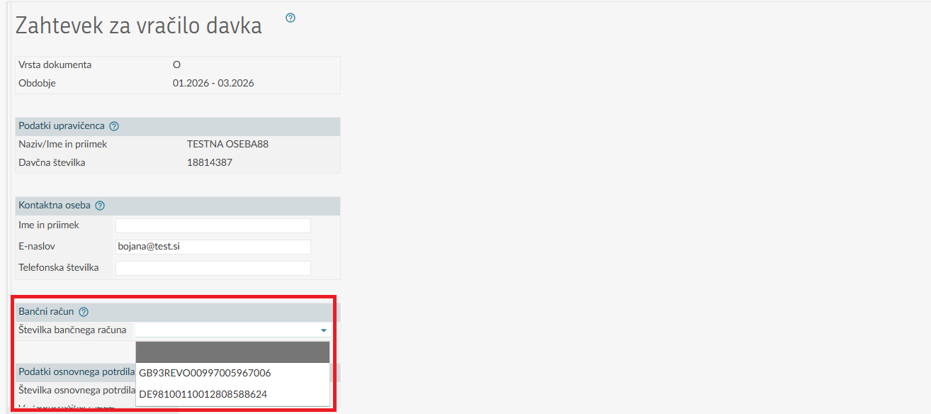

Data of the basic certificate
Data on the basic certificate number, type of exemption, category of the entitled person, date of assuming the position, and exemption according to an international agreement are automatically pre-filled in the claim from the basic certificate.
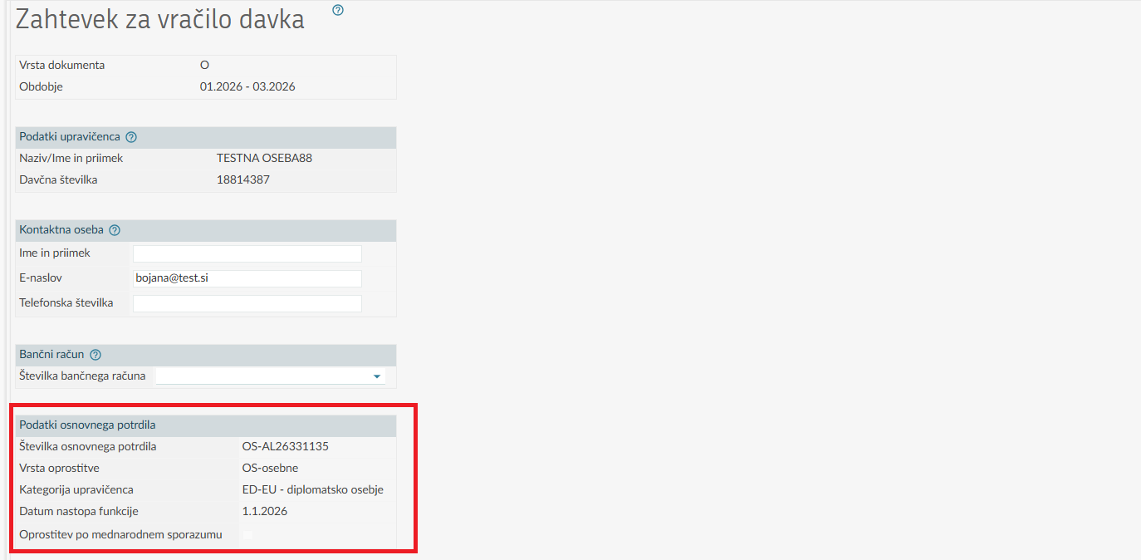

Purchases of goods/services
This part of the claim is intended for entering data on all invoices issued in the period for which the refund of the tax paid is being claimed. Data entry for an individual invoice begins by clicking the »Dodaj račun« (Add Invoice) button, which opens a new entry form.

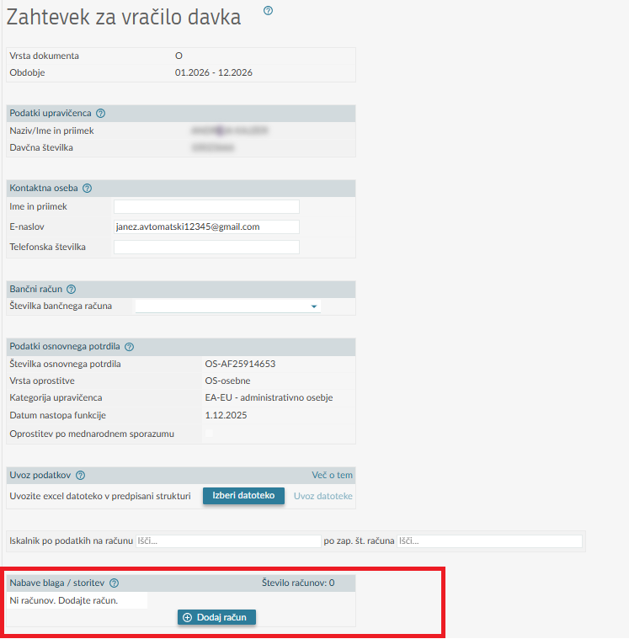

In the »Nabava blaga / storitev« (Goods/Services Purchase) section, invoice data are automatically recorded based on the data entered in the »Podatki o računu« (Data on the invoice) section (invoice number, invoice date, invoice amount, and supplier data (supplier VAT ID and supplier name)). Each invoice entered in the claim receives its own sequential number.

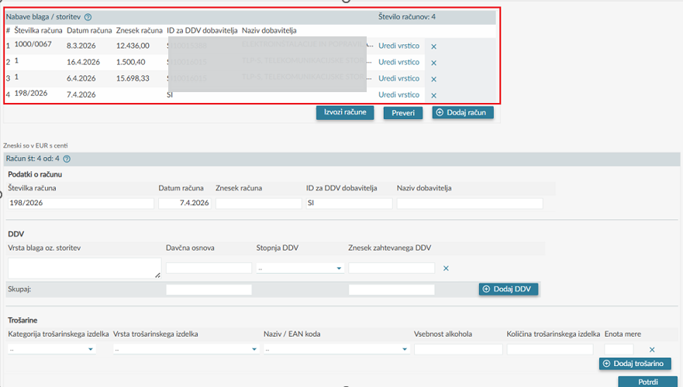
In the »Podatki o računu« (Data about the invoice) section, enter the required data about an individual invoice.

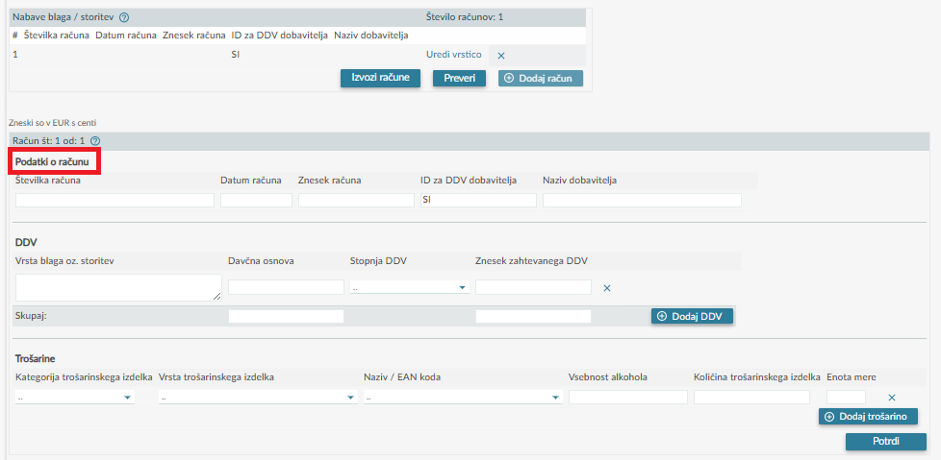

Data about the invoice
The data of all invoices issued during the period in which the refund is claimed are entered, namely the invoice number, the invoice issue date, the invoice amount (the amount actually paid according to the invoice), and the supplier's VAT identification number (supplier's VAT ID). The supplier's name is pre-filled from the Register of Taxable Persons (RDZ) based on the entered supplier's VAT ID and cannot be changed.

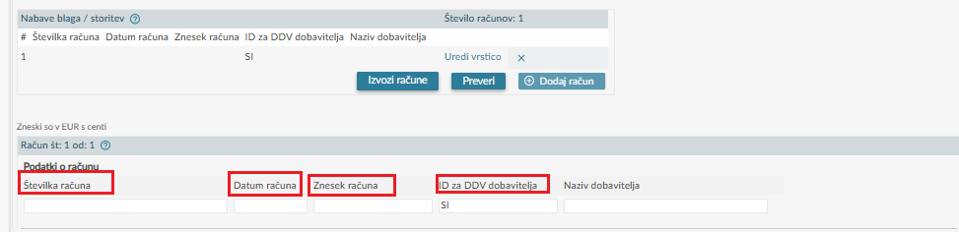

VAT
In the section, which refers to claiming VAT refund, the data are entered on the type of goods or services and on the tax base, and the VAT rate is selected from the drop-down menu according to the identified tax rate for the goods or services from the invoice.

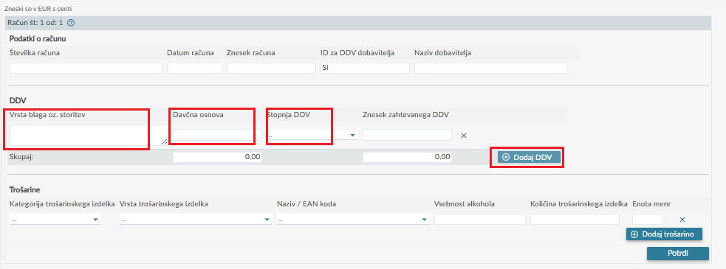

By clicking the »Dodaj DDV« (Add VAT) button, up to three different tax bases can be entered – separately according to the tax rate. The entire row, which specifies the type of goods/services, the tax base, the VAT rate, and the amount of VAT required, can be removed from an individual invoice using the "X" button.

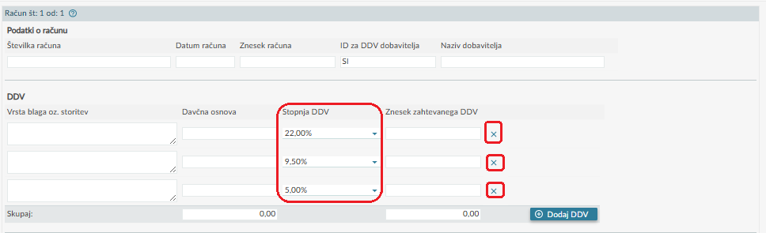

The data on the amount of VAT required is automatically calculated based on the previously entered data on the tax base and the selected VAT rate.

The calculated data of the amount of the requested VAT can be changed as regards the above- mentioned by entering a lower amount in the »Znesek zahtevanega DDV« (Amount of VAT required) field in each line at the selected tax rate, based on the amount of VAT to which the entitled person is actually (still) entitled. The total of the requested VAT amounts is the sum of all VAT amounts that have been calculated or which the entitled person has corrected themselves at each individual tax rate. Manually changing the value in the »Znesek zahtevanega DDV« (Amount of requested VAT) field does not affect the recalculation of other fields (e.g., tax base, tax rate, etc.).

Possible examples of entering a lower amount of the required VAT:
- members of the administrative and technical staff may claim VAT exemption in the first year of their arrival to service in the Republic of Slovenia, for the purchase of household items up to a maximum of 1,200 euros in total exemptions, or in accordance with the limits set in the basic certificate by the Ministry of Foreign and European Affairs (Diplomatic Protocol).
Regardless of the amount of VAT charged on the invoice, the field »Znesek zahtevanega DDV« (Amount of VAT claimed) can include the amount of VAT charged only for household items, and at most up to the amount specified in the original certificate. If the entitled person has already used the exemption in preceding quarterly periods of the first year of arrival to service, then in the current claim they can only request a refund of the tax for the difference between the exemption amount specified in the original certificate and the amount of VAT already refunded in preceding periods.
members of the diplomatic staff may in the calendar year together with family members claim VAT exemption at purchases of goods and services up to the total amount of exemptions, set for an individual country, agency or body of the EU and international organisation or its representation in the basic certificate by the Ministry of Foreign and European Affairs (Diplomatic Protocol).
Regardless of the amount of VAT charged on the invoice, the field »Znesek zahtevanega DDV« (Amount of VAT claimed) can include the amount of VAT, but at most up to the amount specified in the original certificate. If the entitled person has already used the exemption in preceding quarterly periods of the calendar year, then in the current claim they can only request a refund of the tax for the difference between the exemption amount specified in the basic certificate and the amount of VAT already refunded in preceding periods.

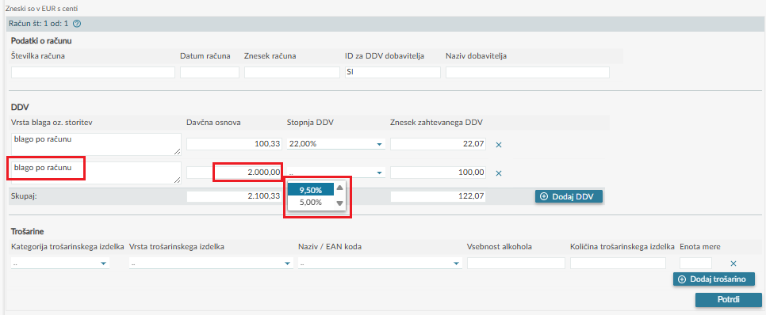

EXCISE DUTIES
If a VAT refund is claimed for products subject to excise duty, an excise duty refund can also be claimed. In this case, the data on products subject to excise duty listed on the invoice are entered in the »Trošarine« (Excise duties) section. We point out that entering data on purchased still wine, sparkling wine, and other fermented beverages is mandatory, even though the excise duty rate for these products is zero (0) euros.

First, select the category of product subject to excise duty (alcohol, tobacco products, energy products, electricity) from the drop-down menu. According to the chosen category of products subject to excise duty, select the appropriate type of excise goods from the drop-down menu, for which you want to claim excise duty refund.

Category »Alkohol in alkoholne pijače« (Alcohol and alcoholic beverages)

In the section »Trošarine« (Excise duties) the data are entered for the following alcoholic beverages:
- beer,
- still wine (e.g. yellow muscat, riesling, chardonnay, grey pinot, cabernet, etc.),
- sparkling wine (e.g. champagne, prosecco, etc.),
- other fermented drinks (e.g. various fruit wines, rice wine, etc.),
- intermediate drinks (e.g. vermouth, Teran liqueur, flavoured wines (e.g. Hugo)) and
- other ethyl alcohol (various alcoholic beverages, such as e.g. pear brandy, whiskey, rum, cognac, liqueurs, etc.).

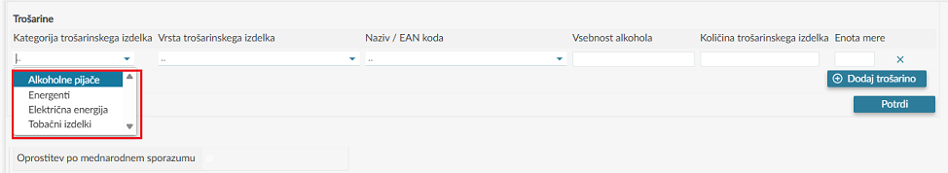

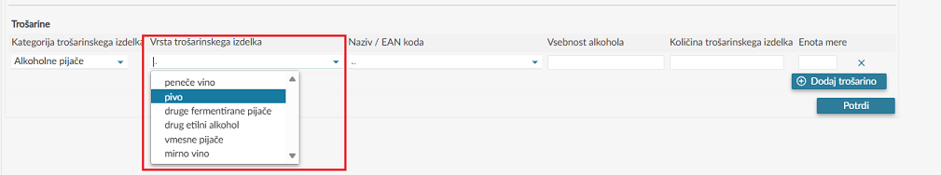

For the type of products subject to excise duty »pivo« (beer) or »drug etilni alkohol« (other ethyl alcohol) the field »vsebnost alkohola (%)« (alcohol content (%)) is filled in with the alcohol percentage shown on the invoice or, if known to the entitled person. The entry of quantities of products subject to excise duty for beer or other ethyl alcohol with the same alcohol content is recorded in the claim jointly, as the sum of quantities with the same alcohol content.

For beer, a pre-filled share in the field »vsebnost alkohola (%)« (alcohol content (%)) of 4.9% is provided, which can be changed by entering the actual »vsebnost alkohola (%)« (alcohol content (%)) for the purchased beer according to each individual invoice.

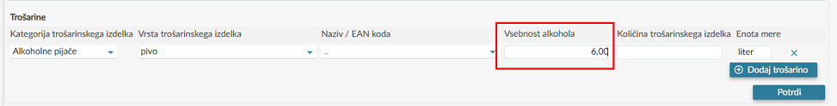

Category »Tobačni izdelki« (Tobacco products)

In the "Trošarine" (Excise duties) section, a refund is claimed for the following tobacco products:
• cigarettes – enter the number of cigarettes (each pack contains 20 cigarettes),
• cigars,
• cigarillos,
• finely cut tobacco,
• other smoking tobacco,
• electronic cigarettes (with and without nicotine), and
• heated tobacco.
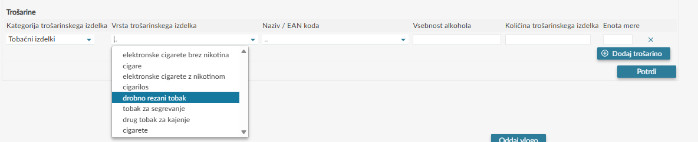

At tobacco products in the field »Naziv/EAN koda« (Name/EAN code) select a name from the dropdown menu or EAN code of the tobacco product (e.g. Marlboro Gold / 3830033510583, etc.).

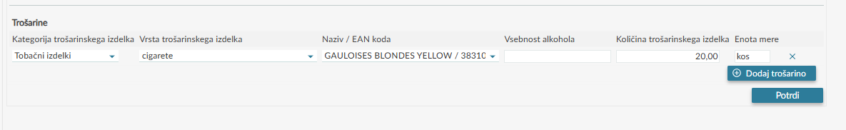

Category »Energenti« (Energy products)

In the section »Trošarine« (Excise duties) the data are entered for the following energy products:
- • gas oil for heating (e.g., fuel oil for heating),
- • kerosene for heating fuel,
- • natural gas for heating fuel, and
- • liquefied petroleum gas for heating fuel.

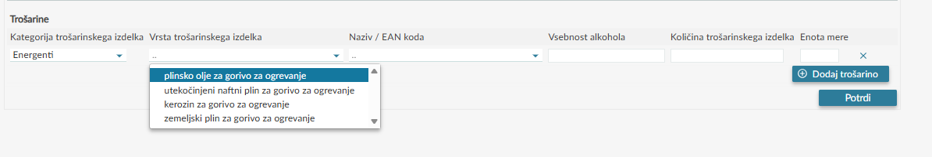

Category »Električna energija« (Electricity)

In the »Trošarine« (Excise Duties) section, data for electricity used as a motive fuel for a vehicle are entered.

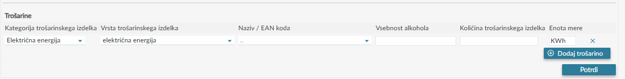

Fields »Količina trošarinskega izdelka« (Quantity of products subject to excise duty) and »Enota mere« (Unit of measurement)

In the continuation of the document, the quantity of the product subject to excise duty is entered for all types of products subject to excise duty.

The unit of measurement is automatically pre-filled based on the selected type of product subject to excise duty.

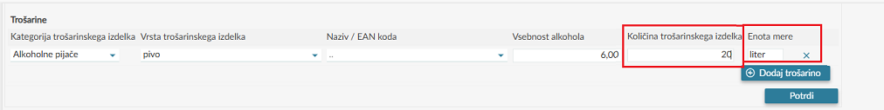

By clicking the button »Dodaj trošarino« (Add excise duty) products subject to excise duty may be added, for which the refund of excise duty is claimed.

An individual product subject to excise duty can be removed from the invoice using the 'x' button.

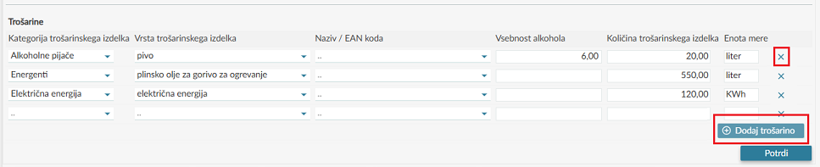

Finishing the entry of data on the invoice and adding the next invoice

When the entry of invoice data is completed, click the »Potrdi« (Confirm) button. This completes the entry of invoice data under the individual sequential number.

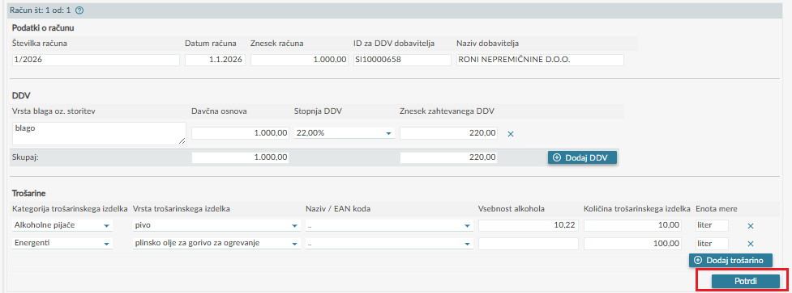

The data are saved and by clicking the »Dodaj račun« (Add invoice) button, the entry of data for the next invoice under a new consecutive number begins.
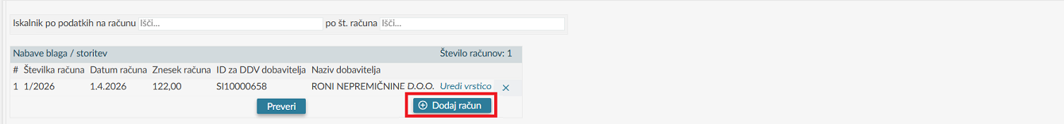

Deleting, editing and checking the data on the invoices
If you want to remove one of the entered invoices, use the 'X' button at the end of the row.

By clicking the »Uredi vrstico« (Edit the row) the already saved data about an individual invoice may be edited.

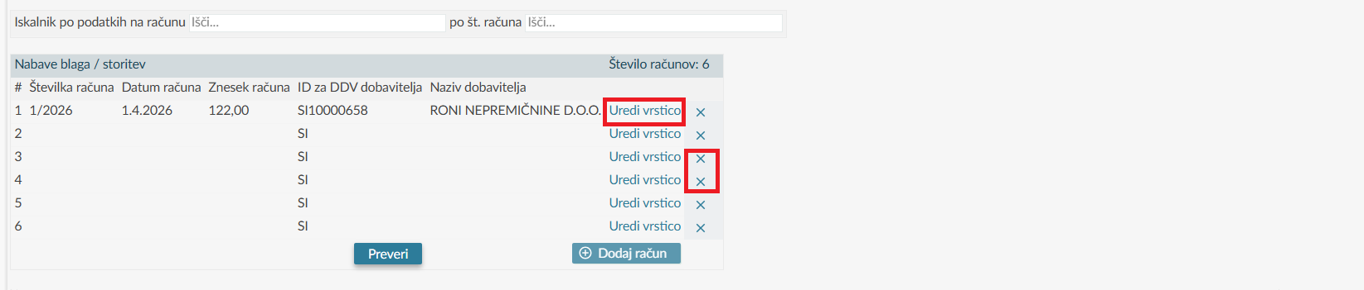
By using the »Preveri« (Check) button, an automatic verification of the entered invoice data can be triggered already during the process of filling out the tax refund request, during which warnings and/or critical errors can be displayed. To successfully submit the request, critical errors must be corrected.

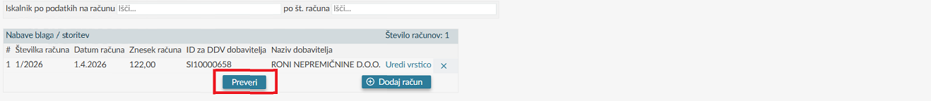

Import and export of data about invoices (excel aid) for the purchased goods/services

Import of data about invoices
On eDavki there is a prepared excel file , which may be used for entry of data about invoices, for which a tax refund is claimed. After entering all invoices into the prepared file, it is then saved to your workstation and then imported into the claim when filling out the tax refund claim (DP-VRA). The file is imported in the manner described below.

The import of file with data about invoices is performed on the claim by selecting the button »Izberi datoteko« (Select a file) in the section »Uvoz podatkov« (Import of data).

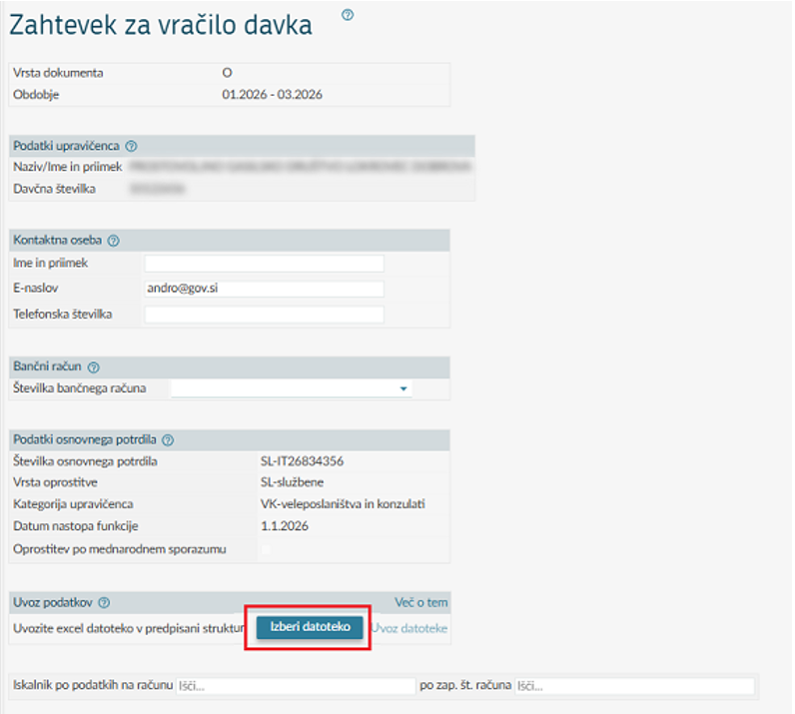

By clicking on »Izberi datoteko« (Select a file), the user searches on his/her computer or local media for the Excel file they want to import and then clicks on »Odpri« (Open).

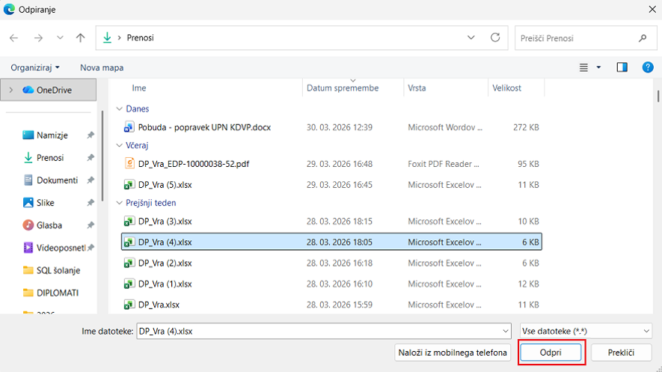
The name of the file is printed on the claim, and the selection of the file is confirmed by clicking the »Uvoz datoteke« (Import of a file).
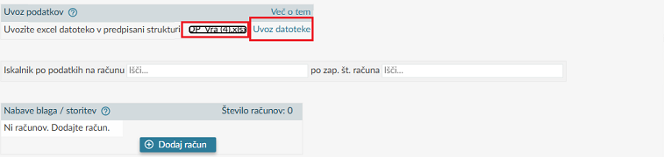
On the screen there is a pop-up window, on which »V redu« (OK) is clicked.
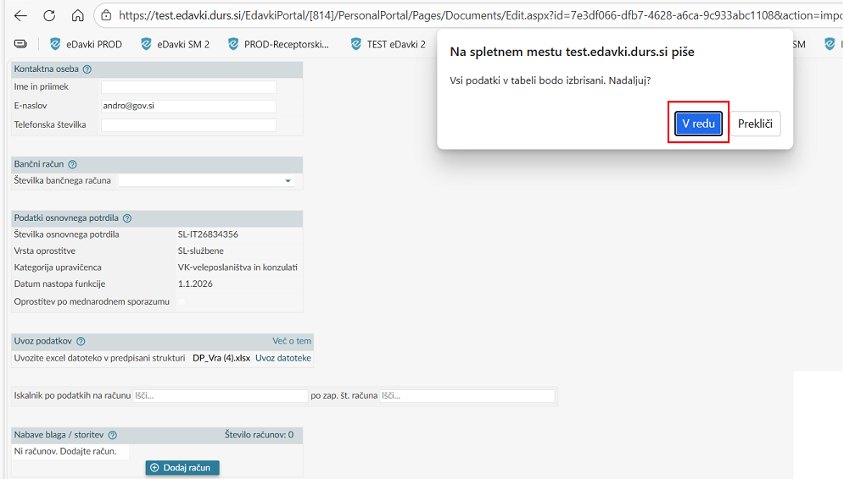
After clicking the button »V redu« (OK) the data are imported into the claim into the section »Nabava blaga/storitev« (Purchase of goods/service).
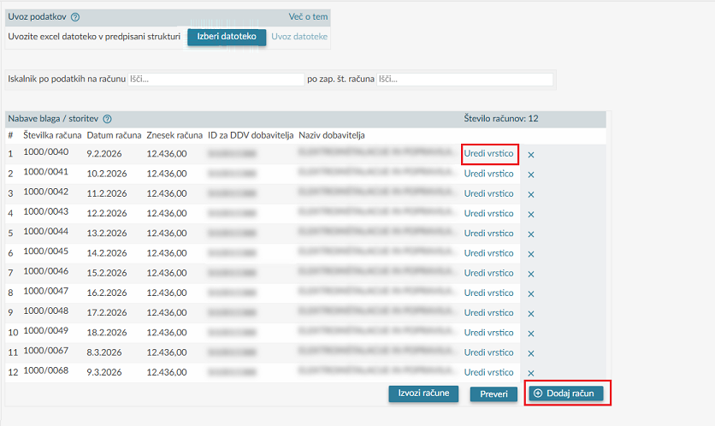
Imported data can be edited by clicking on »Uredi vrstico« (Edit the row). The additional data on invoices may also be entered by clicking on »Dodaj račun« (Add an invoice).

Export of data about invoices into Excel
By clicking the button »Izvozi račune« (Export invoices) the data may be exported from the section »Nabave blaga/storitev« (Purchases of goods/services) into Excel.
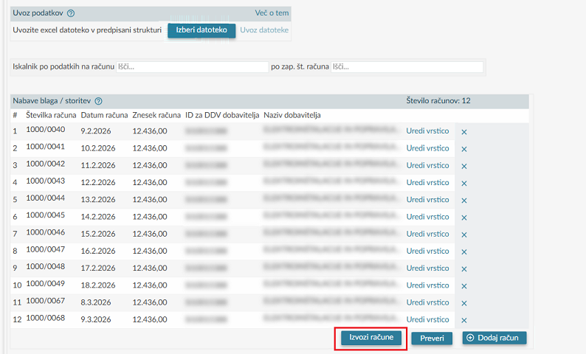
After clicking, the data is exported to an Excel file, which the users can either open or save to their workstation.
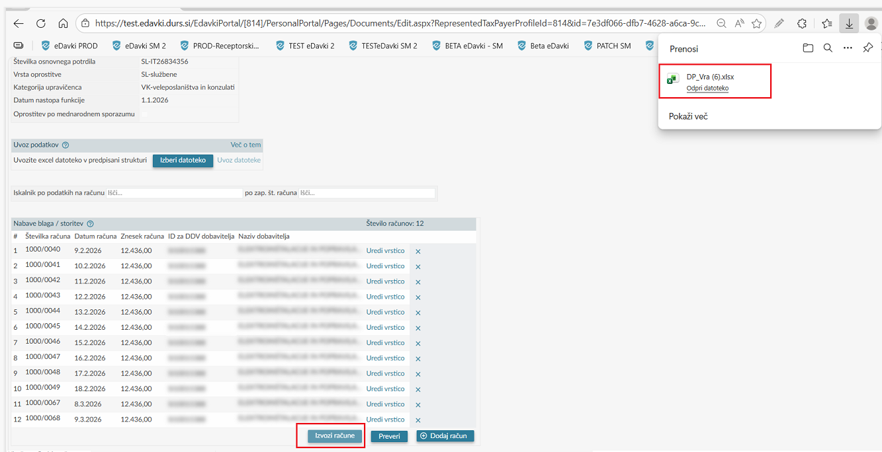

Attachments

Adding attachments before filing the claim (attachments included)
Before submitting the claim, attachments (invoices based on which the tax refund is claimed) can be attached to the electronic claim. In the section »Vsebovane priloge« (Attachments included) the attachments, pre-prepared and pre-saved on a local computer or other external medium, may be transferred by clicking the button »Izberi datoteko« (Select a file).

The file for submission is selected by clicking the button »Odpri« (Open).

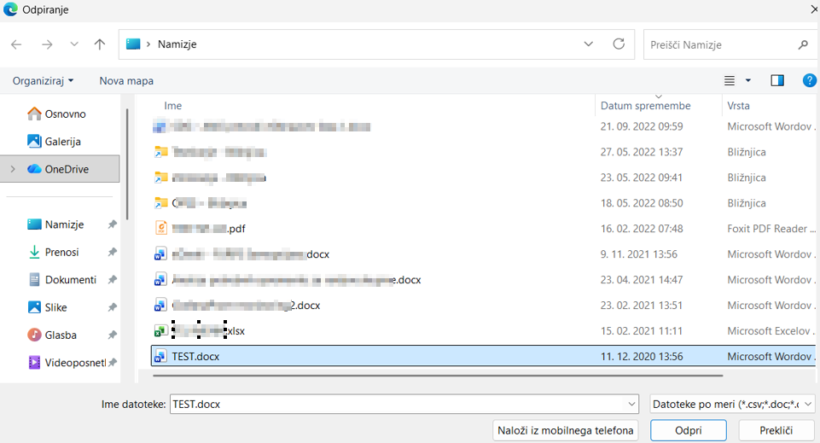
The data are entered into the field »Opis« (description), which is followed by clicking the button »Prenesi datoteko priloge« (Transfer the attachment file).
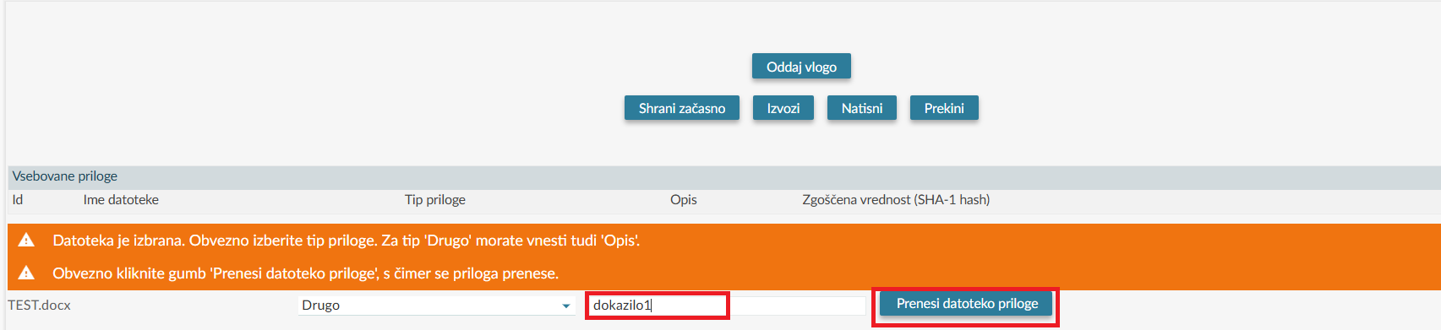
The attachment has been added to the draft tax refund claim in this way.

The added attachment may be deleted by clicking on »X«, a new attachment is added by clicking »Izberi datoteko« (Select a file).
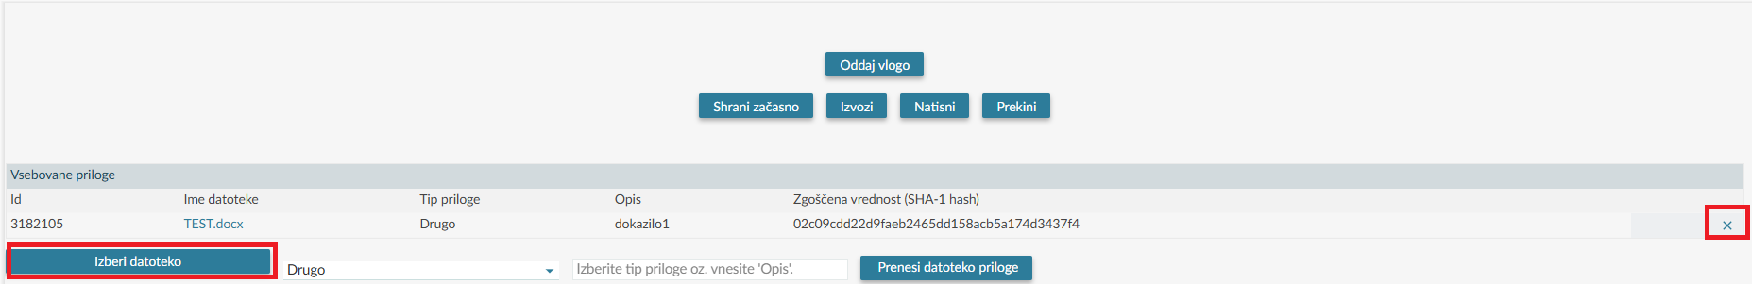

The total size of attachments on an individual claim is limited to 20 MB. If the total size exceeds 20 MB, additional attachments are filed via the eDavki portal in the manner described in Chapter 4.8.2.

Adding attachments on a claim already filed (naknadne priloge - NF-Priloga / subsequent attachments – NF-Attachment)
Upon request of the tax authority, or if the attachments submitted with the tax refund claim exceed 20 MB, invoices based on which a refund of paid tax is claimed can be subsequently attached to an already submitted claim. By clicking on the “Dokumenti” (Documents) menu bar, select “Vloženi” (Submitted), which displays the last 10 submitted documents. The claim to which additional attachments are to be added is found among the submitted documents using additional search criteria, as shown in the image below.

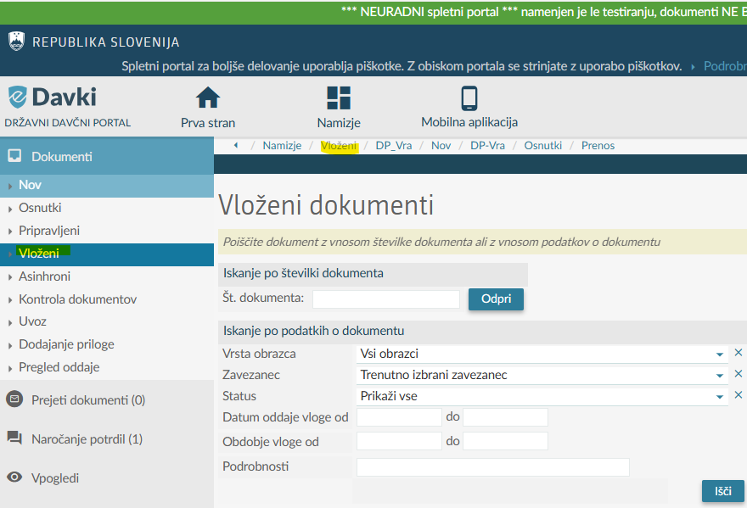

After selecting the claim, the missing/additional attachments may be added by selecting the button »Dodaj prilogo« (Add an attachment).

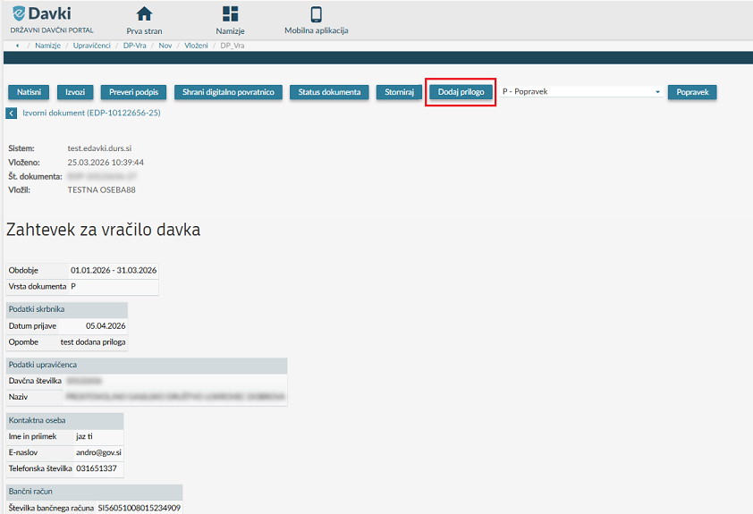

The attachment is attached to the claim in such a way that the button »Izberi datoteko« is clicked and the right file is selected by clicking »Odpri« (Open).

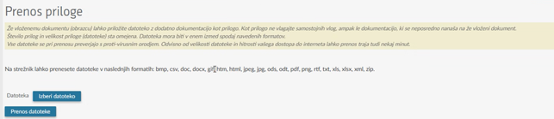
The data are entered into the field »Opis priloge« (Description of the attachment) and the button »Oddaj vlogo« (Submit the application) is clicked.

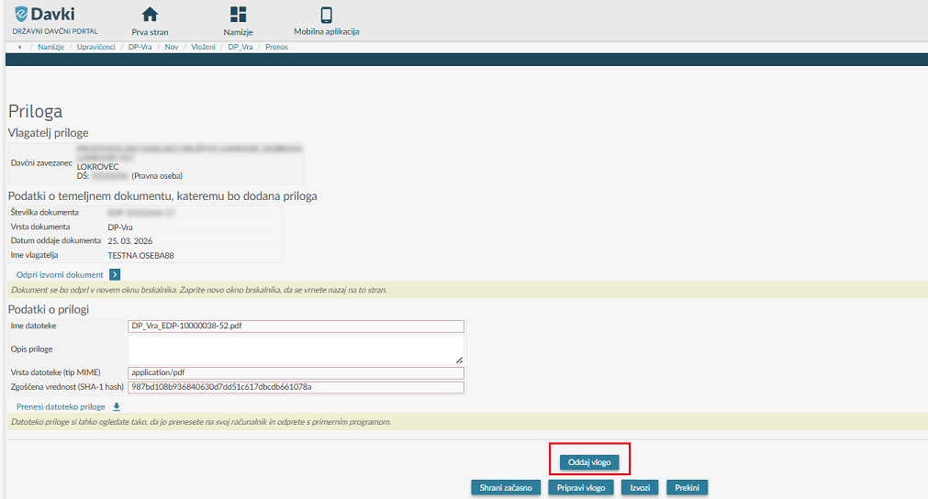
If the data presented on the draft document are appropriate, click the button »Podpis« (Signature) and »NF- Priloga« (NF-Attachment) is submitted. If the data are not appropriate, click the button »Nazaj« (Back) in the browser and you will be returned to the entry form.
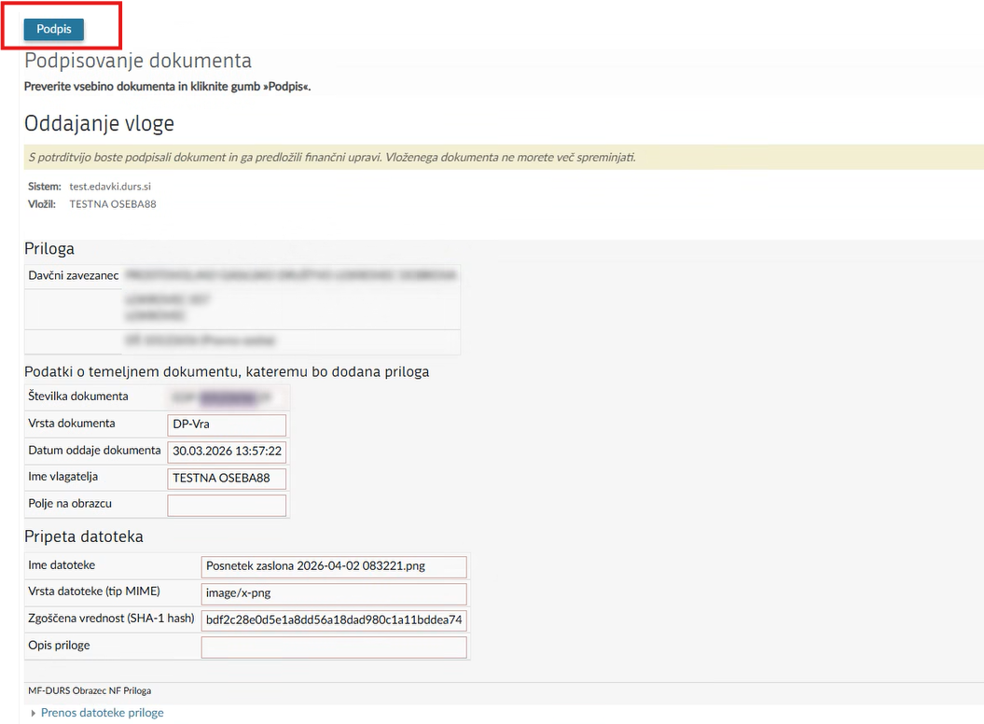

The attachment (NF-Priloga / Attachment) is in this way added to the tax refund claim already filed.

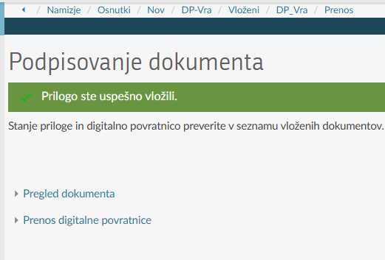

Search engine for invoices
With the search engine, it is possible to easily find entered invoices on a specific claim. The search engine enables searching in two ways:
• searching by invoice data (searching by a partial root of individual data is also possible) and
• searching by invoice sequence number of an invoice or several invoices (individual invoice sequence numbers should be separated by a comma).
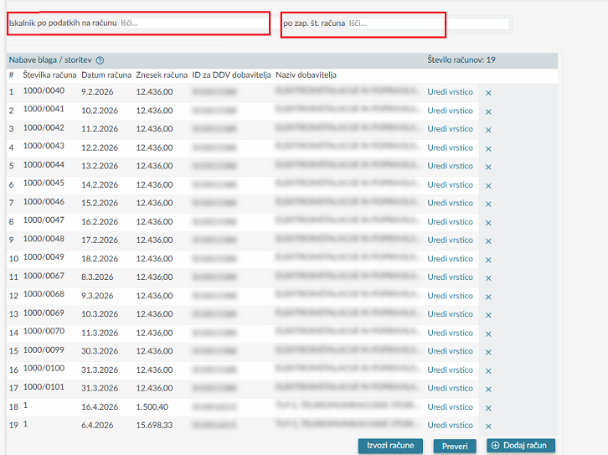
The desired search parameter is entered, and accordingly, the data of the invoice(s) are displayed in the record on the claim.

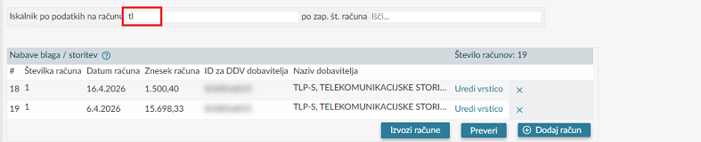

Submission of the tax refund claim
When the entry of data is finished, click the button »Oddaj vlogo« (Submit the application).
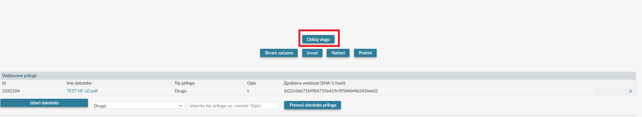
When selecting the button »Oddaj vlogo« (Submit the application), data checks on the claim are automatically performed, where warnings and/or critical errors may be displayed. To successfully submit the claim, critical errors must be corrected.

After correction of all critical errors the content of the claim is displayed. If the data presented on the draft claim are appropriate, click the button »Podpis« (Signature) and the claim is submitted. Before selecting the button »Podpis« (Signature), a user has a possibility to perform a correction of data by clicking the button »Nazaj« (Back) in the browser, which returns the user in the entry form.

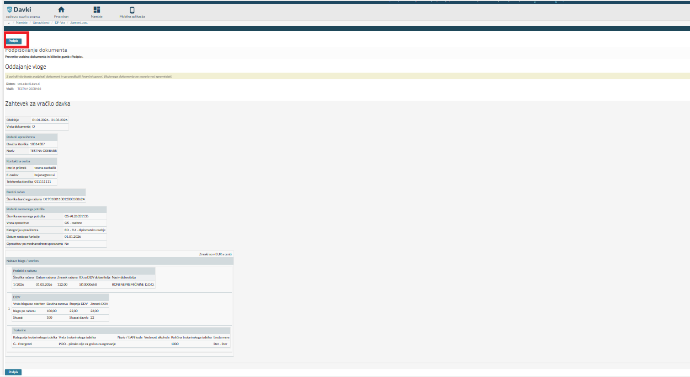

After successful submission the notice »Dokument ste uspešno vložili.« (The document has been filed successfully.) is displayed on the screen. After signature the documents receives EDP number, e.g. EDP-12345678-17211.

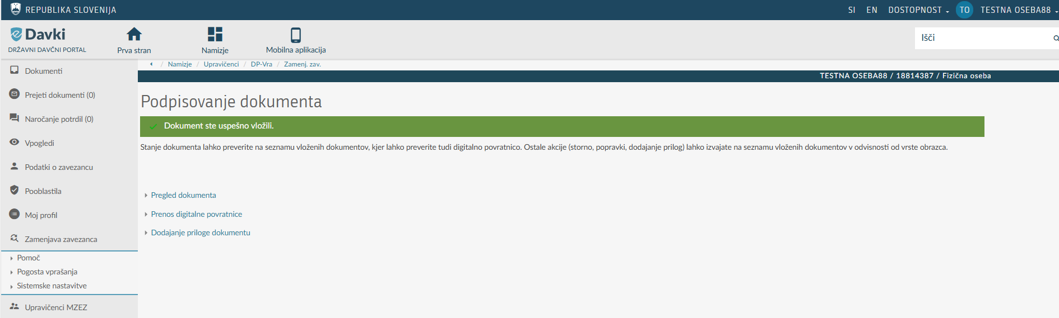
By clicking the link »Pregled dokumenta« (Checking the document) a page opens where the document may be checked, printed, exported in PDF/XML, reversed, an attachment may be added, or a correction of the claim may be filed.

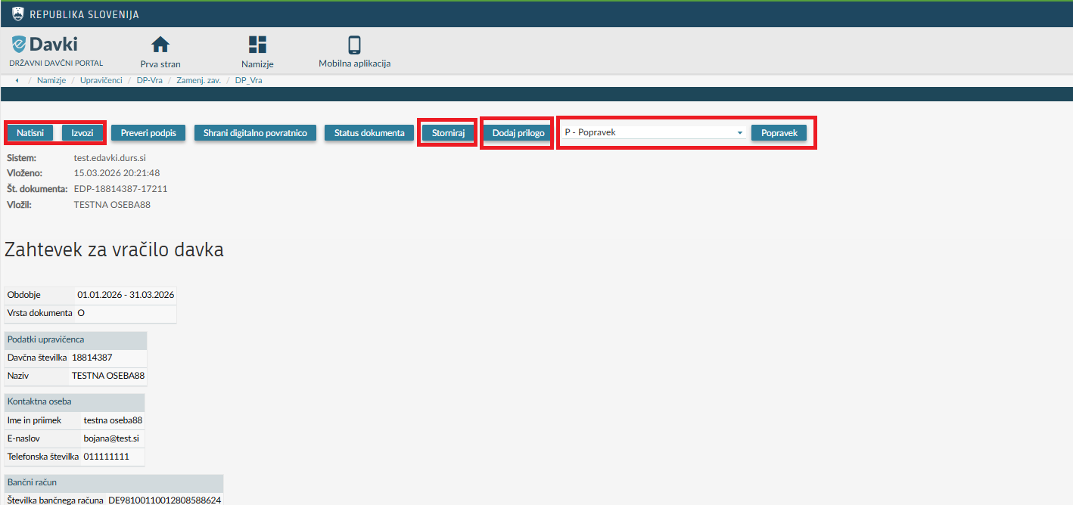

By clicking the button »Natisni« (Print) the system creates a PDF document, which may be saved on a local computer or printed on a local printer.
Correction of the tax refund claim (deleting individual invoices in the claim)
The submitted claims with status »Vložen« (Filed) or »V obdelavi« (In processing) may be corrected. The correction may be submitted until issuing of the administrative act. After clicking the menu row »Dokumenti« (Documents) »Vloženi« (Filed) is selected, where the last 10 filed documents are displayed.

The claim that is to be corrected is searched for among the submitted documents using additional search criteria, as shown in the image below.

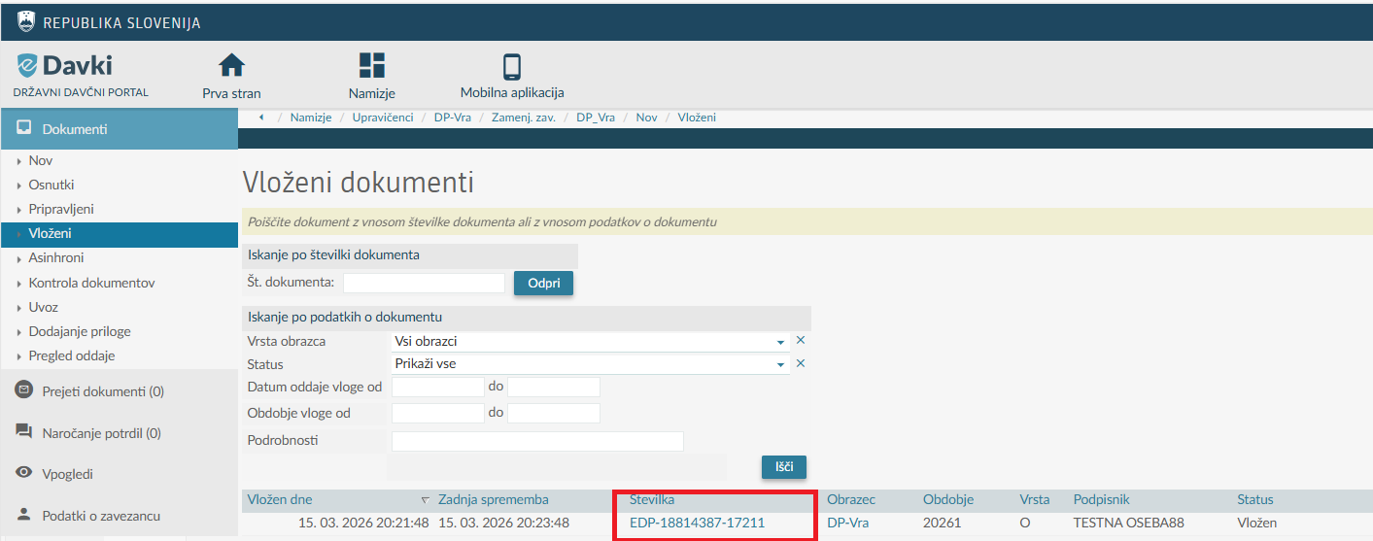
By clicking on the claim number listed in the "Številka" (Number) field, the submitted claim with pre-filled data from the submitted claim opens. By clicking the "Popravek" (Correction) button, only the option to delete individual invoices on the claim is enabled. The invoices displayed from the submitted claim can only be deleted in the correction; they cannot be edited or new invoices added.

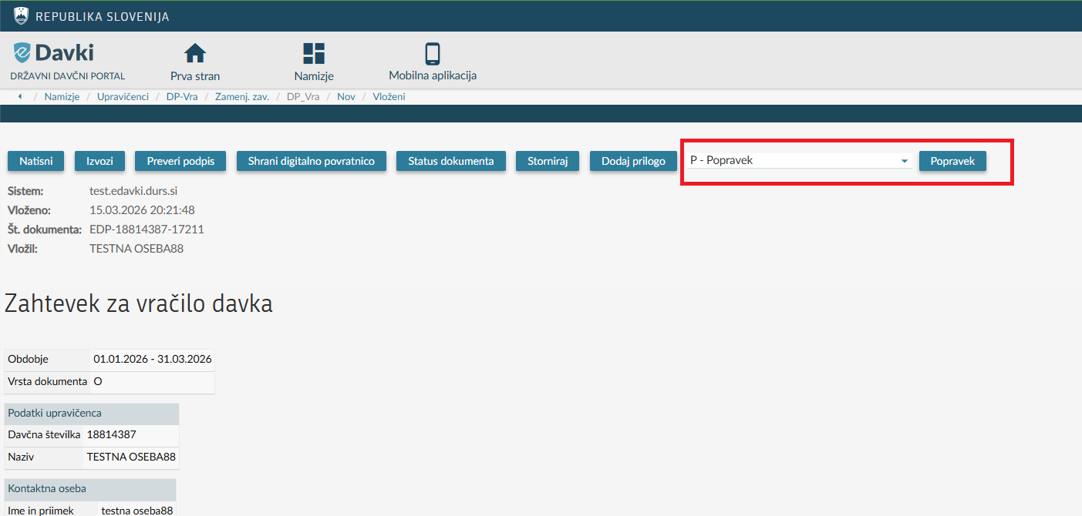
When editing of data is finished, click »Oddaj vlogo« (Submit the application).

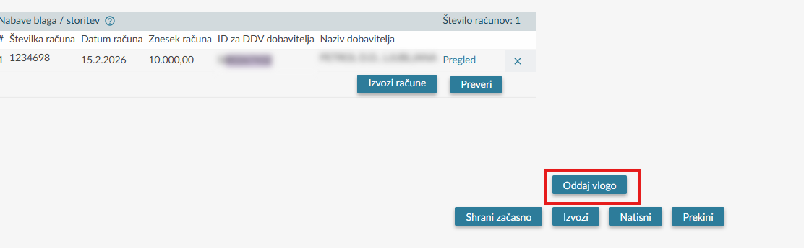

The content of the entered data is displayed again (for review). If the subsequently entered data are correct - appropriate, the claim is submitted by clicking the "Podpis" (Sign) button. If the displayed data are not appropriate, you can return to the entry form, using the "Nazaj" (Back) button in the browser.
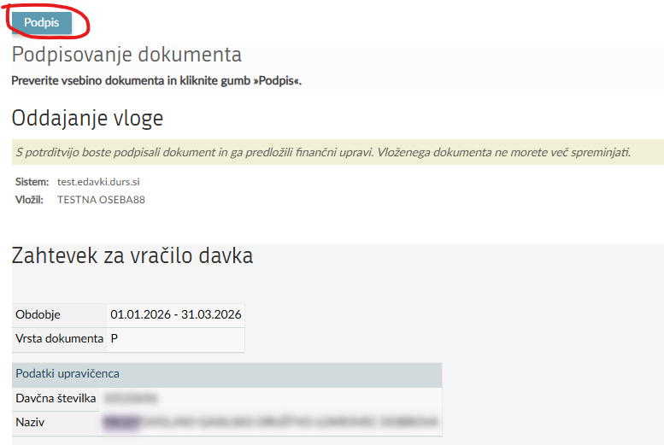

After successful submission of the correction the notice »Dokument ste uspešno vložili.« (The document has been filed successfully.) is displayed on the screen.

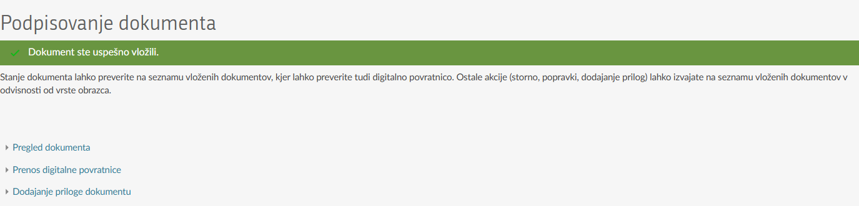

Reversing of the document (Withdrawal of the tax refund claim)
The submitted tax refund claims with status »Vložen« (Filed) or »V obdelavi« (In processing) may be reversed (withdrawn). The document reverse for the claim may be submitted until issuing of the administrative act. After clicking the menu row »Dokumenti« (Documents) »Vloženi« (Filed) is selected, where the last 10 filed documents are displayed.

The claim that is to be reversed (the application withdrawn) is searched for using additional search criteria, as shown in the image below.

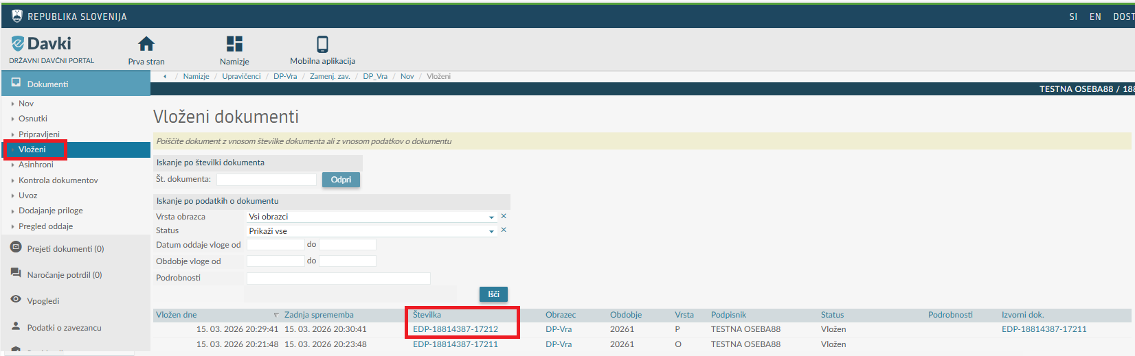

By clicking the document number, stated in the field »Številka« (Number), checking the claim opens. By clicking the button »Storniraj« (Reverse) the entry of data begins for document reverse – withdrawal of application.

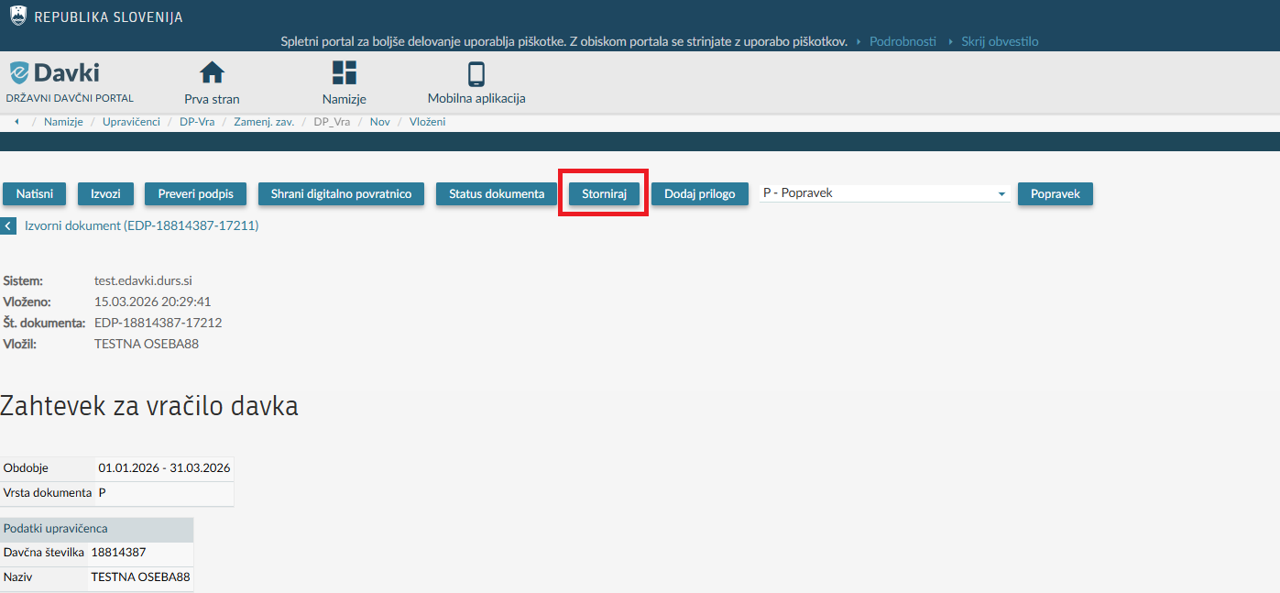
Select »Razlog za stornacijo« (Reason for reverse) and enter the explanation to the field »Dodatna obrazložitev« (Additional explanation).
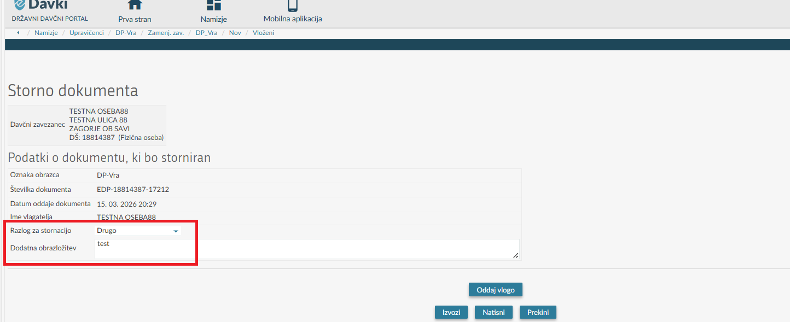
Then you click the button »Oddaj vlogo« (Submit the application).
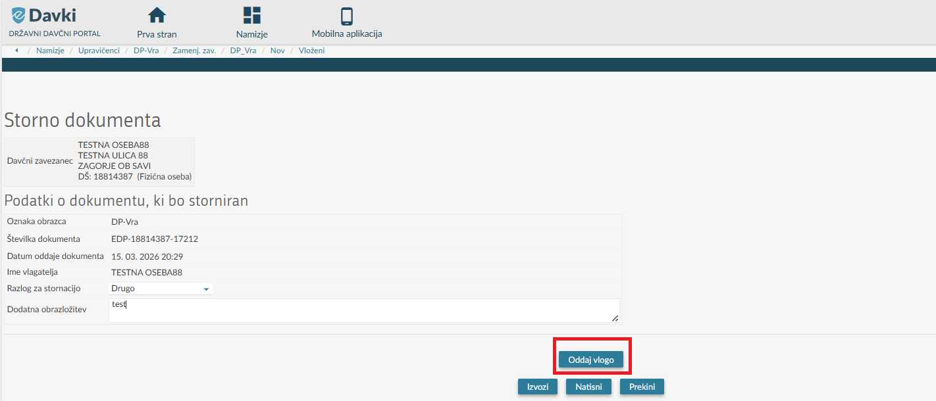
The contents of the entered data are displayed in the overview once again. If the data is correct, the claim is submitted by clicking the “Podpis” (Sign) button. If the data is not correct, you can return to the entry form, using the “Nazaj” (Back) button in the browser.

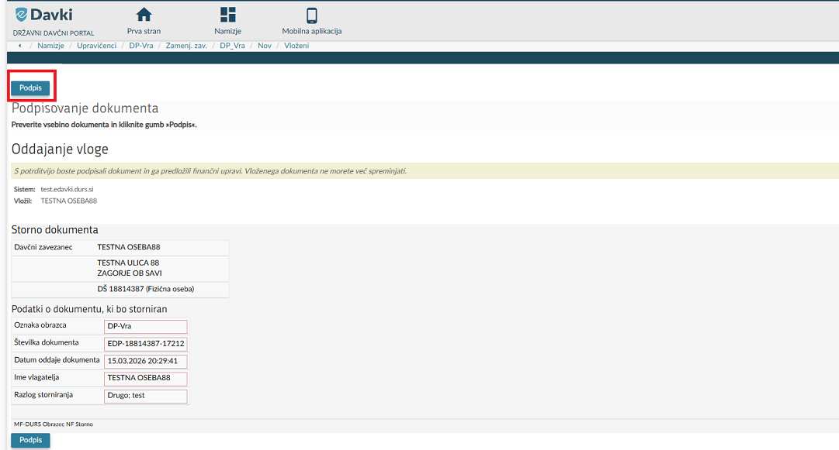
If the withdrawal is successful, the notice »Dokument ste uspešno vložili« (The document has been successfully filed.) is displayed on the screen.
When the document reverse is successfully filed, the cancellation of the above-mentioned document is no longer possible.
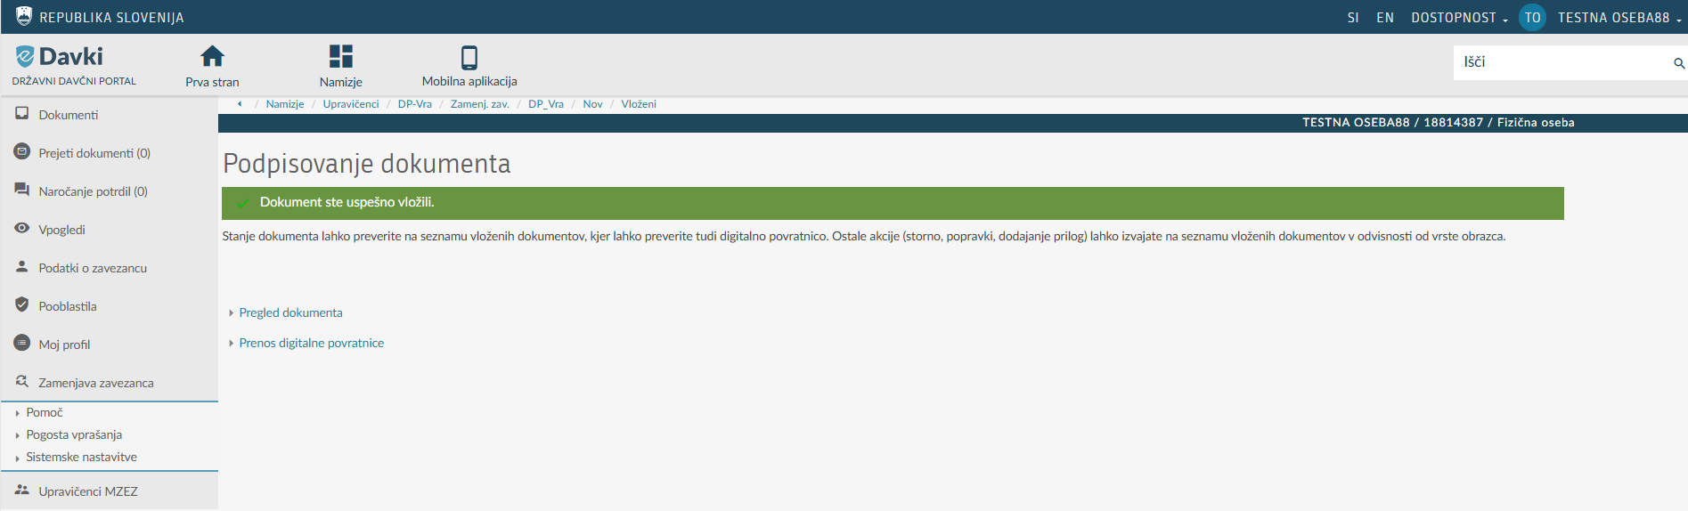

Received documents (administrative acts, issued by the tax authority)
After submitting the claim, the tax authority substantively examines it and decides on it with an appropriate administrative act (decision/order). The tax authority posts the administrative act on the eDavki portal, and the entitled person can view this document in the “Prejeti dokumenti” (Received Documents) section.

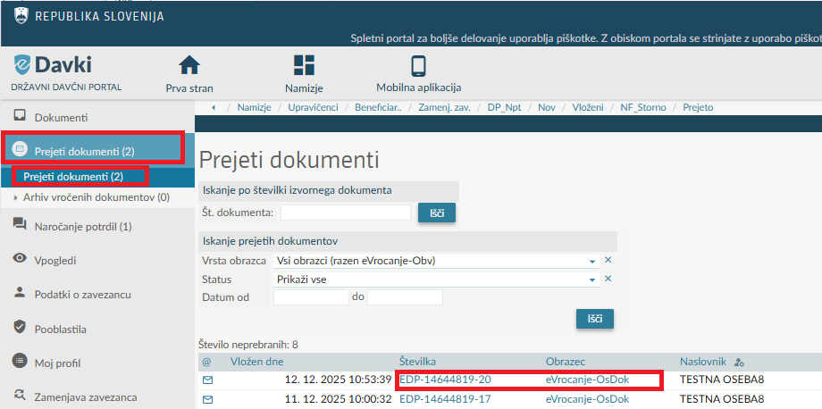
A notice of service of the administrative act posted on the eDavki portal is also sent to the email address provided on the most recently submitted application in the field of "Upravičenci MZEZ" (Entitled persons of MZEZ) (Request for the issuance of a basic certificate, direct certificate, or tax refund). To review the administrative act, it is first necessary to sign the electronic proof of service, only then is it possible to access the content of the electronically received administrative act.
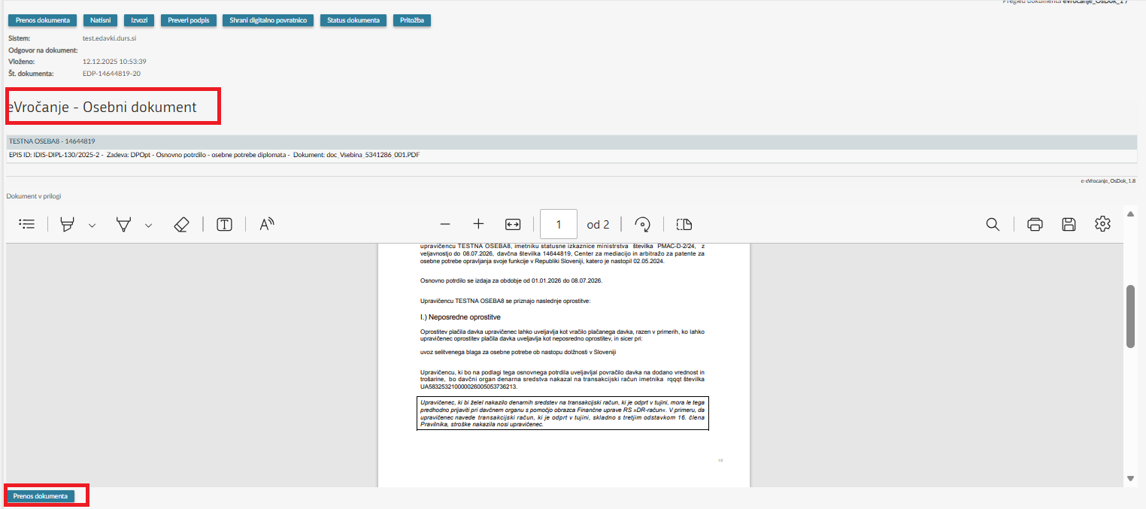
The content of the received administrative act may be saved to a local computer and/or printed.

